My Qi (Chee) and Me.
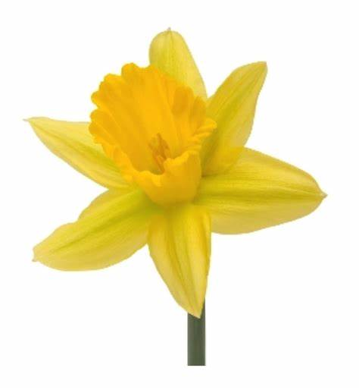

When in Spring the daffodils grow,
Our Qi builds to give us power.

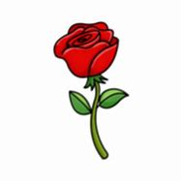
When in Summer the roses grow,
Our Qi builds hour by hour.

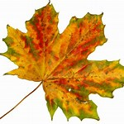
When in Autumn the leaves fall,
Our Qi may reduce but we still
have power,

When in Winter the snow falls,
But our Qi keeps us warmer by
the hour.

